NOTICE
OF DEVELOPMENT
PROPOSAL
F
CITY OF BEAVERTON
Community Development Department
Planning Division
12725 SW Millikan Way
PO Box 4755
Beaverton, OR 97076
Tel: (503) 526-2420
Fax: (503) 526-2550
www.beavertonoregon.gov

Notice Date: August 17, 2017
Project Name: |  | Bank of America at 8505 SW Beaverton Hillsdale Hwy.
Case File No.: |  | DR2017-0085 – Design Review 2
Summary of  Application: |  | The applicant, Gensler Company, proposes a new building intended for bank services which will include a drive-up window and automated teller machines (ATMs). The new building would be one story, approximately 22 feet in height and approximately 4,420 feet in size. This development proposal includes 32 parking spaces and perimeter landscaping. The subject property is located in the city Community Service (CS) commercial zone where financial institutions are permitted outright. At this time, 24 hour operation of ATMs is not proposed but may be proposed in the future under separate Conditional Use application. In the CS zone, uses operating between 10:00 p.m. and 7:00 a.m. require Conditional Use approval when the use/property is located within 500 feet of an existing residential use and zone. This would include the 24-hour operation of all ATMs. The application subject to this notice, Design Review 2, includes review of the proposed building location and all site improvements, including the location of the drive-up ATMs.
Project Location: |  | The subject site is located on the north side of SW Beaverton Hillsdale Highway, west of SW Poplar Lane and east of SW Whitepine Lane and is addressed as 8605 SW Beaverton Hillsdale Highway. The project site is also identified as Tax Lots 300 and 400 on Washington County Assessor’s Map 1S1 14AD. Development will mostly occur on Tax Lot 400 which is the property located closest to SW Beaverton Hillsdale Hwy (see attached map).
Zoning & NAC: |  | Community Service (CS) / Denney Whitford - Raleigh West NAC
Applicable Development Code Criteria: |  | Section 40.03 Facilities Review; Section 40.20.15.2.C Design Review Two.
Staff Contact: |  | Primary Contact: Scott Whyte, Senior Planner, 503.526.2652 / swhyte@beavertonoregon.gov or Travis Goddard, Planning Manager,  (503) 526-2557
Mailed written comments in response to this development proposal should be sent to the attention of Scott Whyte, Planning Division, 12725 SW Millikan Way, P.O. Box 4755, Beaverton, OR 97076. To be made part of the record, written comments need to be received by Wednesday, September 20, 2017, 4:30p.m. Please reference the Case File Number and Project Name in your written comments.

Facilities Review Committee Meeting Date: September 20, 2017

No public hearing is scheduled for this Design Review 2 proposal. On September 20, 2017, Facilities Review Committee, consisting of city staff, will meet to discuss the proposal with the applicant. The Facilities Review Committee is not a decision-making body, but advises the Planning Director on a project’s conformity to the technical criteria specified in Section 40.03 of the Beaverton Development Code. The Planning Director will include the Committee’s recommendation and findings in the Notice of Decision that is issued following the Facilities Review meeting.
The Director’s decision may be viewed at: http://apps.beavertonoregon.gov/DevelopmentProjects

A copy of the pre-application conference notes, plans and all other documents and evidence submitted by or on behalf of the applicant, and applicable review criteria, are available for inspection at the Beaverton Planning Division, 4th floor, Beaverton Building, 12725 SW Millikan Way, between the hours of 7:30 a.m. and 4:30 p.m. Monday through Friday, except holidays.

Failure to raise an issue or failure to provide statements or evidence with sufficient specificity to afford the decision-making authority an opportunity to respond to such issue, may preclude appeal to the Land Use Board of Appeals on that issue.

Accessibility information: This information can be made available in large print or audio tape upon request. Assistive listening devices, sign language interpreters, or qualified bilingual interpreters can be made with advance notice. To request these services, contact Scott Whyte by calling 711 (503) 526-2652 or email swhyte@beavertonoregon.gov.

PROPOSED SITE PLAN
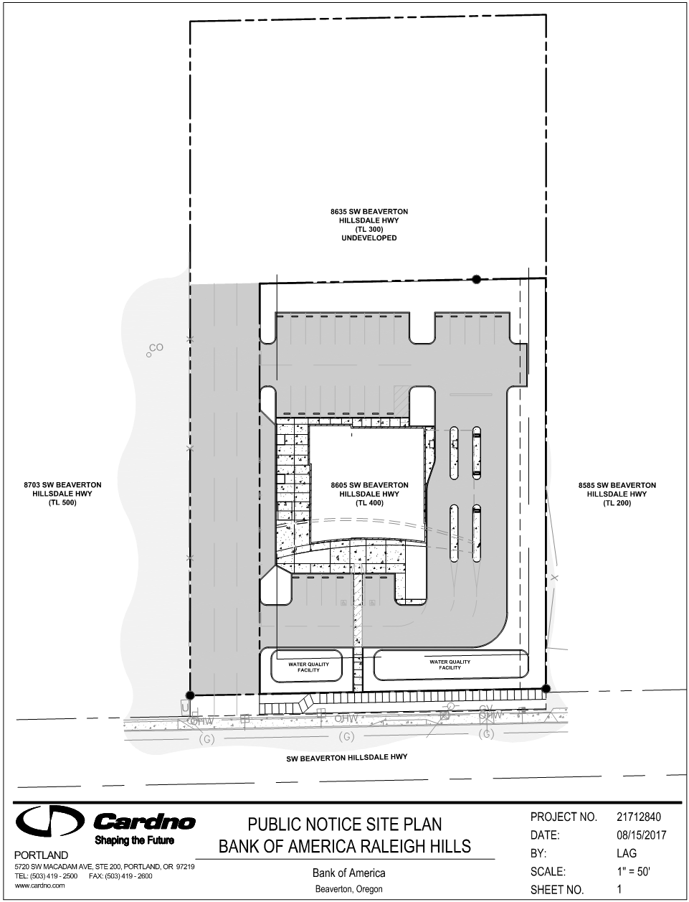
N

